Guided reading homework- Fletcher
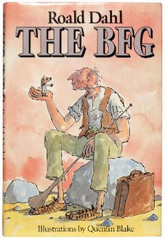
Please read “The Giants”.
- Why did the BFG have to snatch Sophie from her bed?
- What does the BFG mean when he says that Sophie will come to an ucky mucky end?
- Can you write 3 descriptive sentences as if you were Sophie watching the giants? Think about the language you choose to use.
- What do you think the BFG means by “sometimes I is left instead of right”?
Pre-read- please read “The marvellous ears” and consider why Sophie thinks the BFG is a strange and moody creature.

