Ratburger
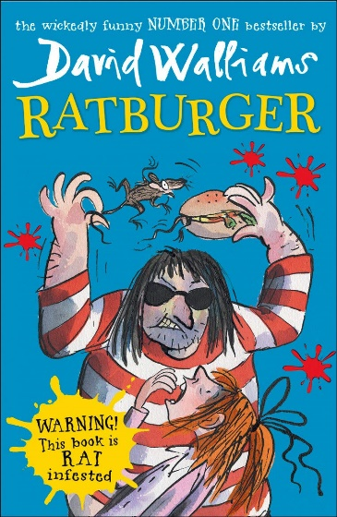
Please read chapter 5

- What does “Zoe trudged even more reluctantly” tell you about the way she was walking?
- Why do you think Dad was crying on page 53?
- Why do you think he was hiding his sadness from his daughter?
- Why do you think Zoe speaks “sheepishly”?
- In what way is Raj mistaken about Poppadom?

Pre-read chapter 6 - Opinions on the story so far?

