The Boy Who Grew Dragons

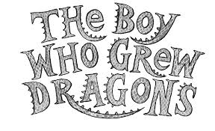

Please re-read chapter 4 and 5 and answer the following questions.

- What does it mean if something is aloft?
- Why isn’t Chipstick feeling cool about the dragons?
- What makes the dragon seem cute?
- Why does mum wake up?
- What do you think Chipstick should do about the dragon?

Please read chapter 6 and 7 for homework.

