Judy Moody Saves the World
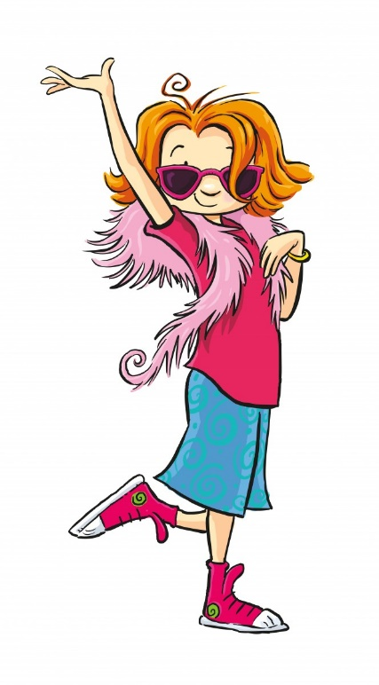
Please re-read chapter 11 and answer the following questions.
- Why did Judy and Rocky think the teachers were acting funny?
- How many bottles were collected?
- How many trees will be planted?
- What did all of the students in Class 3T receive?
- What big surprise did Ms. Tuxedo have for Judy?
- How did Judy react?

