The Boy Who Grew Dragons
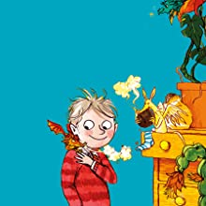
Please re-read chapter 12 and 13 and answer the following questions.
- Find phrases that show Tomas is panicking.
- What shows Liam’s lack of intellect?
- Why was Lolli screaming?
- How did Liam fall over?
- Predict whet Liam’s present might be.
Please read chapter 14 and 15 for homework.

