Guided reading homework- DiCamillo
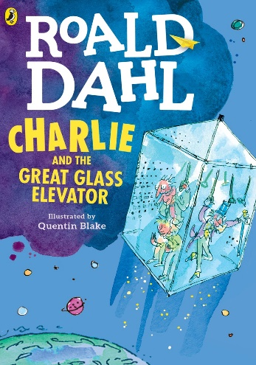
Please read chapter 6+7- the answers can be found in chapter 6
- Why was Mr Wonka “doubled up with silent laughter”? pg 58
- Why does Mr Wonka say they can’t go back to the White House? Pg 60
- Choose two made up words in Mr Wonka’s rhyme (pg 62). Can you create your own definitions for them?
- Can you create your own verse?
- Why is the last sentence of chapter 6 effective in gripping the reader?
Pre-read- chapter 8. Can you decide on 2* and a wish for Mr Wonka’s poem about the Knids (pg77)?

