Guided reading homework- Fletcher
Please read “Snozzcumbers”
- What do you think “happy eats” means?
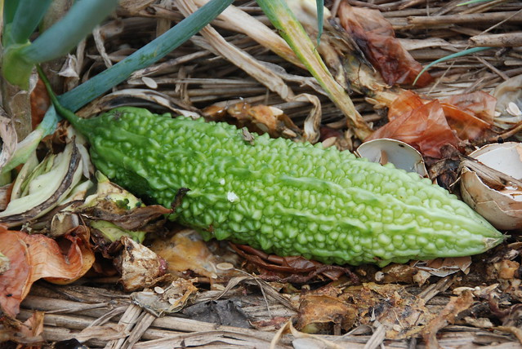
- Choose one of the animals on page 40. Draw what you think it may look like and write 3 descriptive sentences about them.
- What do you think squoggle, mispise and dispunge mean? Why?
- What 2 things are strange about giants?
Pre-read- please read “The Bloodbottler”. Think about the way Bloodbottler says people from different countries taste different. Can you think of anymore?

