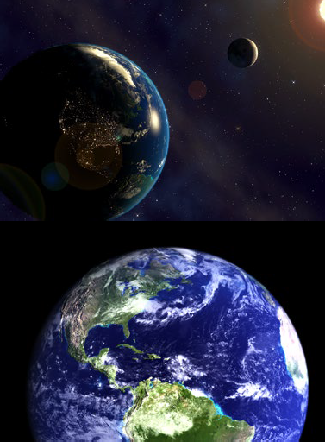
Planet Earth
Have you ever wondered why humans live on Earth and not the other planets in our Solar System? Well, Earth is the only planet in our solar system that has all the things we need to survive: 21% oxygen in the air to breathe, water to drink and all at just the right temperature warmed by the Sun. Scientists call this the ‘Goldilocks Zone’ because everything is ‘just right’…not too hot, not too cold. Its name is derived from the Old English word ‘ertha’ and the Anglo-Saxon word ‘erda’ which means ground or soil.

The Blue Planet
Earth, the third planet from the Sun after Mercury and Venus, is referred to as ‘The Blue Planet’ because of how it looks from space. This is due to the fact that over ⅔ of the Earth’s surface is covered in oceans and seas.
Did you know?
- Age: approx. 4.54 billion years
- Diameter: 13,000 km
- Distance to Sun: 150,000,000 km
- Surface Temperature: 15°C
- Highest point: Mount Everest 8.8 km
- Lowest point: Challenger Deep 10.9 km below sea level

I’m Spinning Around
The Earth spins on its axis once every 24 hours – that’s what gives us day and night. You wouldn’t notice but the Earth’s spin is actually slowing down by 17 milliseconds per hundred years. Eventually this will lengthen our days but it will take around 140 million years before our day will have increased from 24 to 25 hours. I wonder if children 140 million years from now will have an extra hour at school.
Whilst it is spinning, the Earth is also orbiting the Sun, which takes 365 ¼ days to do one full circuit. This gives us the length of our years. Our seasons are also dependent on the orbit of the Earth as our planet is tilted at an angle. This means that around one side of the Sun we are tilted towards it – giving us warmer temperatures and longer days…our summer. However, around the other side of the Sun we are tilted away from it giving us less light and cooler temperatures – so this is our winter. All in all, it’s a pretty amazing planet and I, for one, am glad to call it home.

Questions
- What percentage of the air we breathe is not Oxygen?

- What is the difference between the highest and lowest points on Earth?

- How long does it take the Earth to spin once on its axis?

- Will the Earth always spin at this speed? If not, how will it change?

- How many planets are between us and the Sun and can you name them?

- Why do we experience summer around one side of the Sun?

- In the Fact File section the author has written ‘approx.’, what is the reason for the full stop in this word?

- In the ‘I’m Spinning Around’ section, the author writes:

You wouldn’t notice but the Earth’s spin is actually slowing down by 17 milliseconds per hundred years’
Why does the author say we wouldn’t notice?

- Why do we need to add an extra day to our year every 4 years?

- Which fact or piece of information has amazed you the most and why?

Answers
- What percentage of the air we breathe is not Oxygen?

79%
- What is the difference between the highest and lowest points on Earth?

19.7km (10.9 + 8.8)
- How long does it take the Earth to spin once on its axis?

24 hours/1 day
- Will the Earth always spin at this speed? If not, how will it change?

No – it is slowing down
- How many planets are between us and the Sun and can you name them?

2 (Mercury and Venus)
- Why do we experience summer around one side of the Sun?

The Earth is tilted towards The Sun
- In the Fact File section the author has written ‘approx.’, what is the reason for the full stop in this word?

To abbreviate the word – full word: approximately Discuss: why do this? Can you think of other examples?
- In the ‘I’m Spinning Around’ section, the author writes:
You wouldn’t notice but the Earth’s spin is actually slowing down by 17 milliseconds per hundred years’
Why does the author say we wouldn’t notice?

Discuss: Because the decrease is happening so gradually/slowly
- Why do we need to add an extra day to our year every 4 years?

Due to the fact we have an extra ¼ day every year we orbit The Sun
- Which fact or piece of information has amazed you the most and why?

Open ended to discuss.

