Stephanie Peters

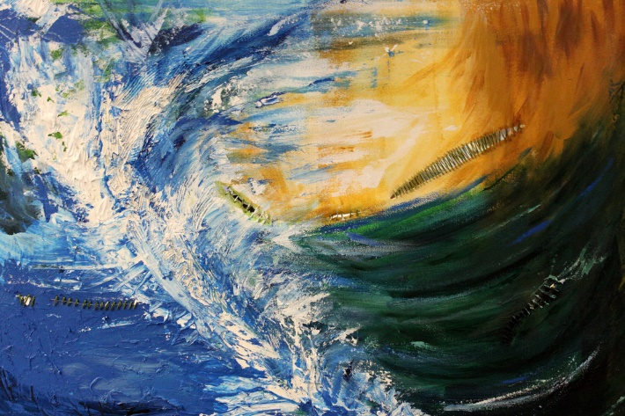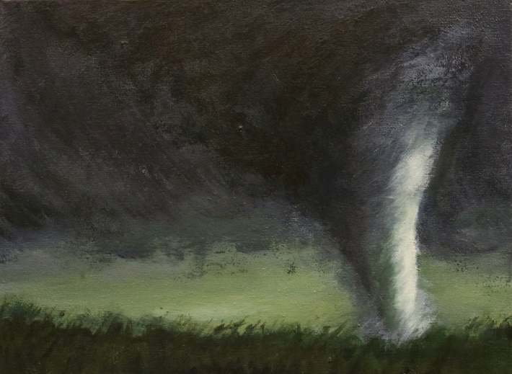

What I like about this piece of art.

What I don’t like about this piece of art.

What I like about this piece of art.

What I don’t like about this piece of art.

What I like about this piece of art.

What I don’t like about this piece of art.

What I like about this piece of art.

What I don’t like about this piece of art.

