Guided reading homework- Blackman
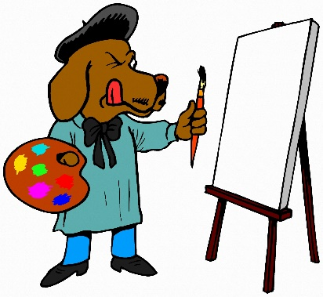
Please read chapters 20, 21 + 22
- Can you summarise each chapter in less than 15 words? (so less than 45 words altogether!)
- Draw an illustration for one chapter of your choice
- For a different chapter, choose 2 things you like about it and 1 thing you’re not keen on.

