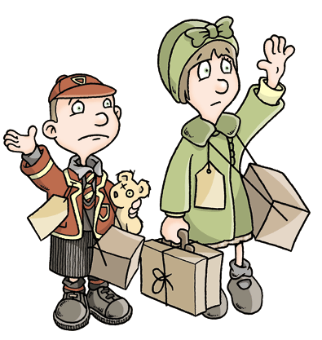
Was it right to evacuate children during the war?
For
- Cleaner air
- Better food – home-grown vegetables and meat
- Avoid air raids occurring over the cities
- Taste of living in the countryside – new and exciting
- Opportunity to make new friends
Against
- Cultural shock for many children
- Families split up at what is already a difficult time
- No allocated foster parents – children selected upon arrival.
- Agonising experience for children chosen last
- Emotional upheaval having to move from family, friends, school, places they know
- Children often home-sick and anxious wondering if they’d have a home or family to go back to
Word bank
Firstly, Additionally, Moreover, Furthermore, Also,
As well as this/that, Despite this , No one can deny that
However, On the other hand, On the contrary, Although Therefore, Consequently, So, with this in mind,
Subsequently,
Generalised speaker | Word to describe how to put point across
Many children | said, believed, stated, argued, suggested, claimed,
The British government
It was
Teachers
Parents
Some evacuees

