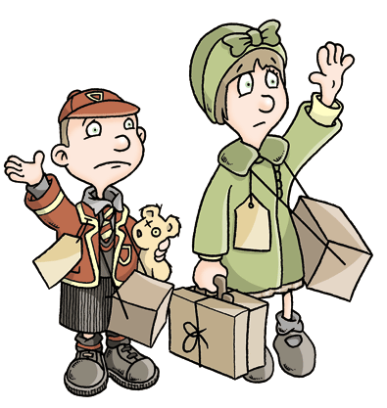
Was it right to evacuate children during the war?
During the war (World War Two), many children, disabled people, pregnant women and nursing mothers were evacuated from their city homes to rural areas to avoid the expected air raids by German enemies. The operation (known as Operation Pied Piper) began in September 1939 and saw nearly two million people relocated in three days. The British government broadcast that evacuation was not only a necessity for these vulnerable groups but that it was an exciting and enjoyable experience for all. However, was this the case?
No one can deny that living in the countryside was a safer option because it was believed that schools and homes could also be destroyed during the bombings as well as the targeted factories. Therefore, cities were dangerous places to reside. Additionally, many children stated that they enjoyed the taste of living in the countryside as it was a new and exciting experience for them as well as a fantastic opportunity to make new friends. Furthermore, many claim that they felt healthier due to breathing in cleaner, fresher air and eating home-made food cooked with home-grown vegetables.
However, it was argued that for some children, being an evacuee was far from being a pleasant experience. Firstly, some teachers claimed that evacuation was too much of an emotional upheaval for many of the youngsters and that many became home-sick. Also, the children often became anxious and withdrawn as they couldn’t be sure if they would have a home or parents to go back to. Moreover, for some, it was an agonising experience being selected on arrival at a village hall after a long journey. As well as this, some children stated that they were taunted by the locals with comments made about their cleanliness and intelligence.

