Name _____________ 4.2.2021

Year 5 Science – Space - Lesson 4

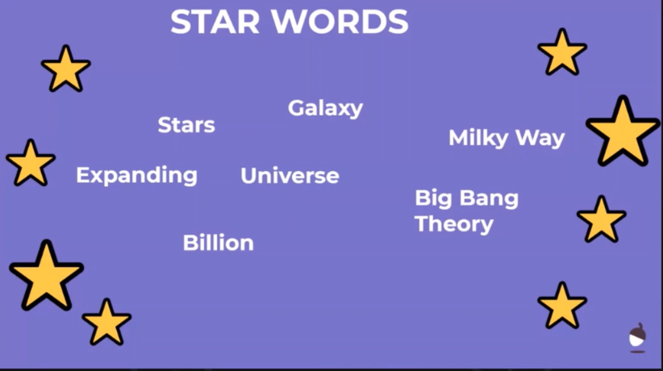

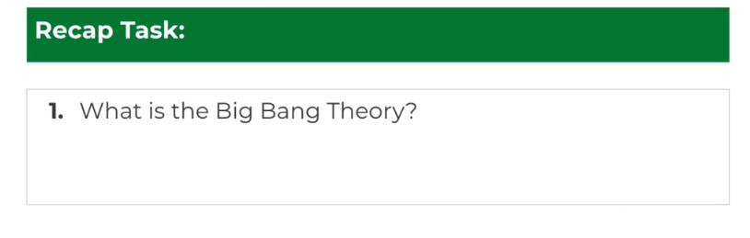

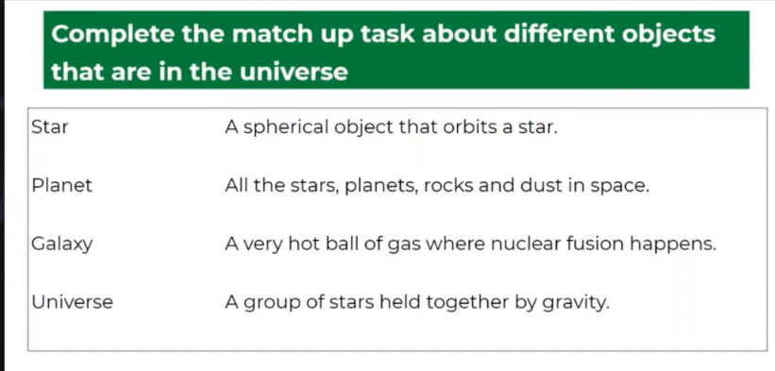

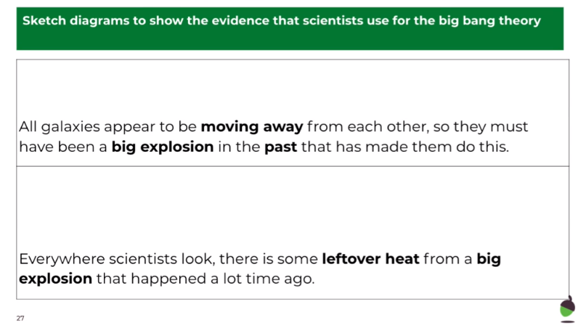



You will need

a marker pen

a balloon

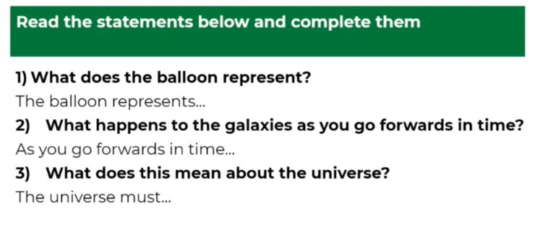

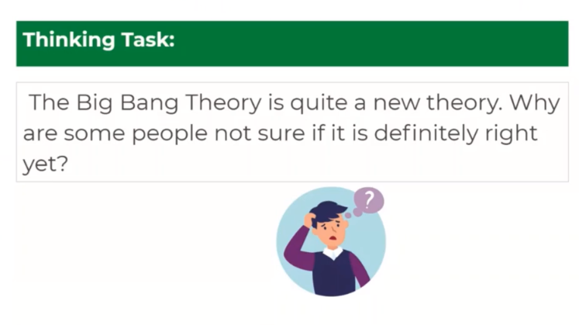

What do you think?

_____________________________________________________________________________________________________________________________________________________________________________________________________________________________________________