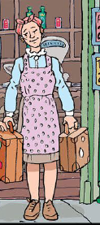

Kind and caring – she look after Carrie and Nick from the start.

Fearful

Apprehensive

Nervous – on page 25, her eyes keep darting to the clock and she’s hurrying the children for no reason.

She seems to be scared of her brother. On page 22, she uses a hushed voice as she showed the children his room. On page 24, she pleads with them to be good children so she doesn’t get into trouble. On page 33, it says she was scared he’s come back in.

On page 21, it says she is strong as she carries all of the children’s bags.

On page 21, it says she has reddish, brown hair and bright, button eyes.

Timid – on page 21 it says she has a shy, quivering look.