**[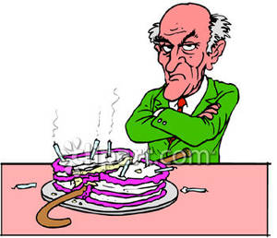](http://www.google.co.uk/url?sa=i&rct=j&q=&esrc=s&source=images&cd=&cad=rja&uact=8&ved=0ahUKEwjzxoucurDPAhWM8RQKHXgoCAUQjRwIBw&url=http://www.picturesof.net/pages/090427-221031-581009.html&bvm=bv.134052249,d.ZGg&psig=AFQjCNEc_B5dBJiZLLRrLnm0i7PstYtZXw&ust=1475096802705054)Mr Evans**

Aggressive

Punctual

Spiteful

Unappreciative

Conceited

Meticulous