[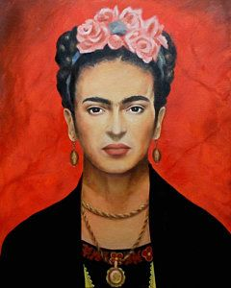](https://www.google.com/url?sa=i&url=https://www.pinterest.com/pin/510877151470927867/&psig=AOvVaw2NO3rbYgQ_Xi8-qumNn1Ka&ust=1612126473536000&source=images&cd=vfe&ved=0CAIQjRxqFwoTCJiEr6DFxO4CFQAAAAAdAAAAABAT)[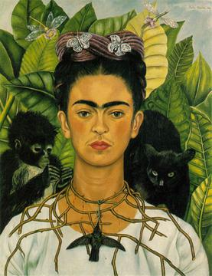](https://www.google.com/url?sa=i&url=https://en.wikipedia.org/wiki/Self-Portrait_with_Thorn_Necklace_and_Hummingbird&psig=AOvVaw2NO3rbYgQ_Xi8-qumNn1Ka&ust=1612126473536000&source=images&cd=vfe&ved=0CAIQjRxqFwoTCJiEr6DFxO4CFQAAAAAdAAAAABAN)

[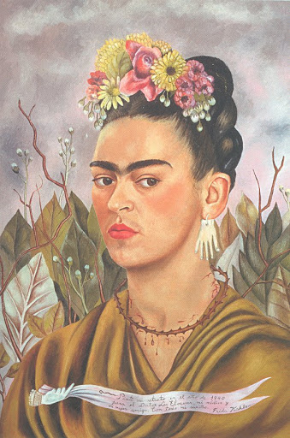](https://www.google.com/url?sa=i&url=http://www.sai.msu.su/cjackson/kahlo/p-kahlo19.htm&psig=AOvVaw2NO3rbYgQ_Xi8-qumNn1Ka&ust=1612126473536000&source=images&cd=vfe&ved=0CAIQjRxqFwoTCJiEr6DFxO4CFQAAAAAdAAAAABAs)

[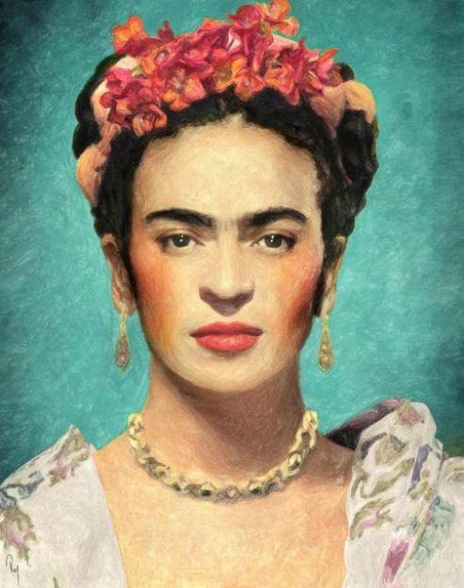](https://www.google.com/url?sa=i&url=https://numeralpaint.com/products/people-frida-kahlo-self-portraits-paint-by-numbers/&psig=AOvVaw2NO3rbYgQ_Xi8-qumNn1Ka&ust=1612126473536000&source=images&cd=vfe&ved=0CAIQjRxqFwoTCJiEr6DFxO4CFQAAAAAdAAAAABAZ)

[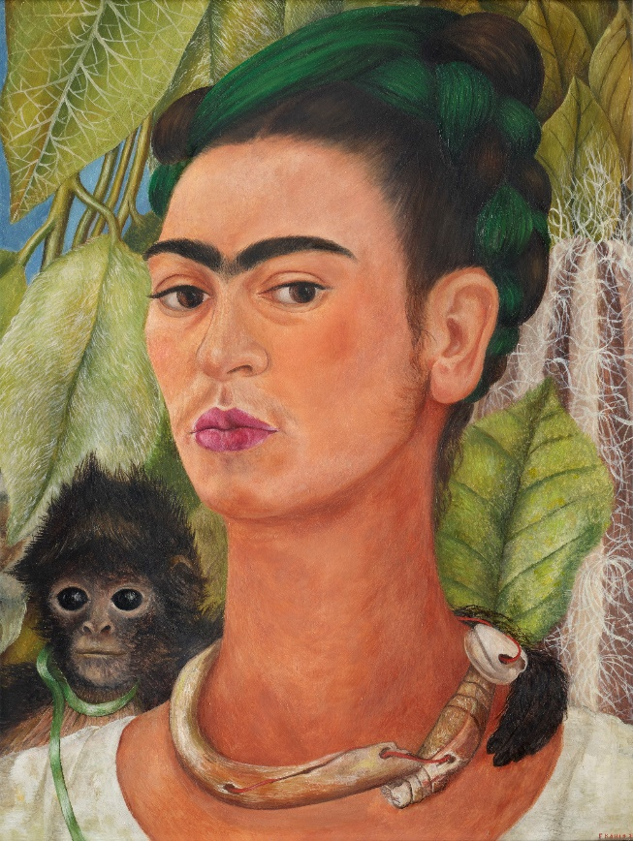](https://www.google.com/url?sa=i&url=https://www.artsy.net/article/artsy-editorial-frida-kahlos-self-portraits-helped-embrace-flaws&psig=AOvVaw2NO3rbYgQ_Xi8-qumNn1Ka&ust=1612126473536000&source=images&cd=vfe&ved=0CAIQjRxqFwoTCJiEr6DFxO4CFQAAAAAdAAAAABAx)

[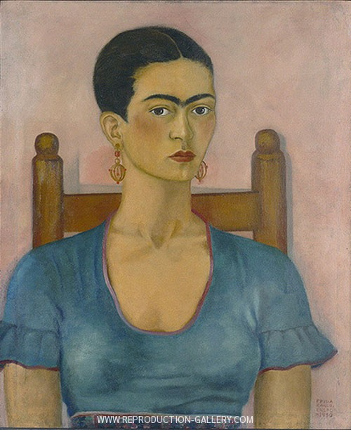](https://www.google.com/url?sa=i&url=https://www.reproduction-gallery.com/oil-painting/1022579047/frida-kahlo-self-portrait-1930-by-frida-kahlo/&psig=AOvVaw2NO3rbYgQ_Xi8-qumNn1Ka&ust=1612126473536000&source=images&cd=vfe&ved=0CAIQjRxqFwoTCJiEr6DFxO4CFQAAAAAdAAAAABBC)[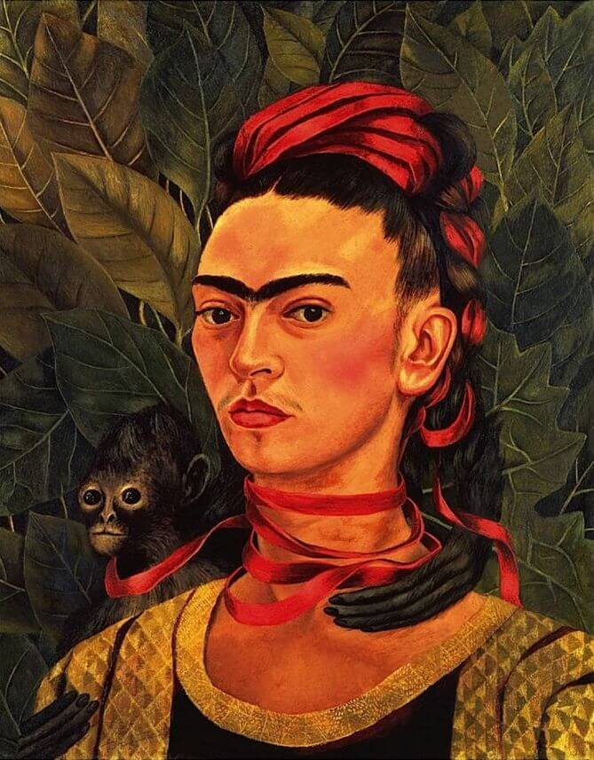](https://www.google.com/url?sa=i&url=https://www.fridakahlo.org/self-portrait-with-monkey-1940.jsp&psig=AOvVaw2NO3rbYgQ_Xi8-qumNn1Ka&ust=1612126473536000&source=images&cd=vfe&ved=0CAIQjRxqFwoTCJiEr6DFxO4CFQAAAAAdAAAAABA8)

[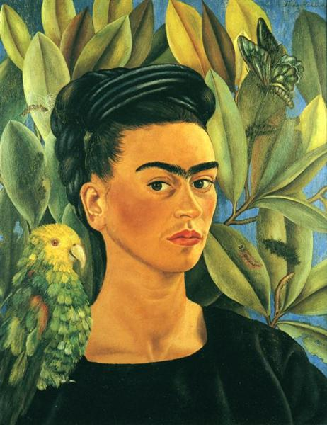](https://www.google.com/url?sa=i&url=https%3A%2F%2Fwww.wikiart.org%2Fen%2Ffrida-kahlo%2Fself-portrait-with-bonito-1941&psig=AOvVaw16Pfv6dCLPegBlGTqQTfUX&ust=1612127096932000&source=images&cd=vfe&ved=0CAIQjRxqFwoTCPCV1cnHxO4CFQAAAAAdAAAAABAF)

[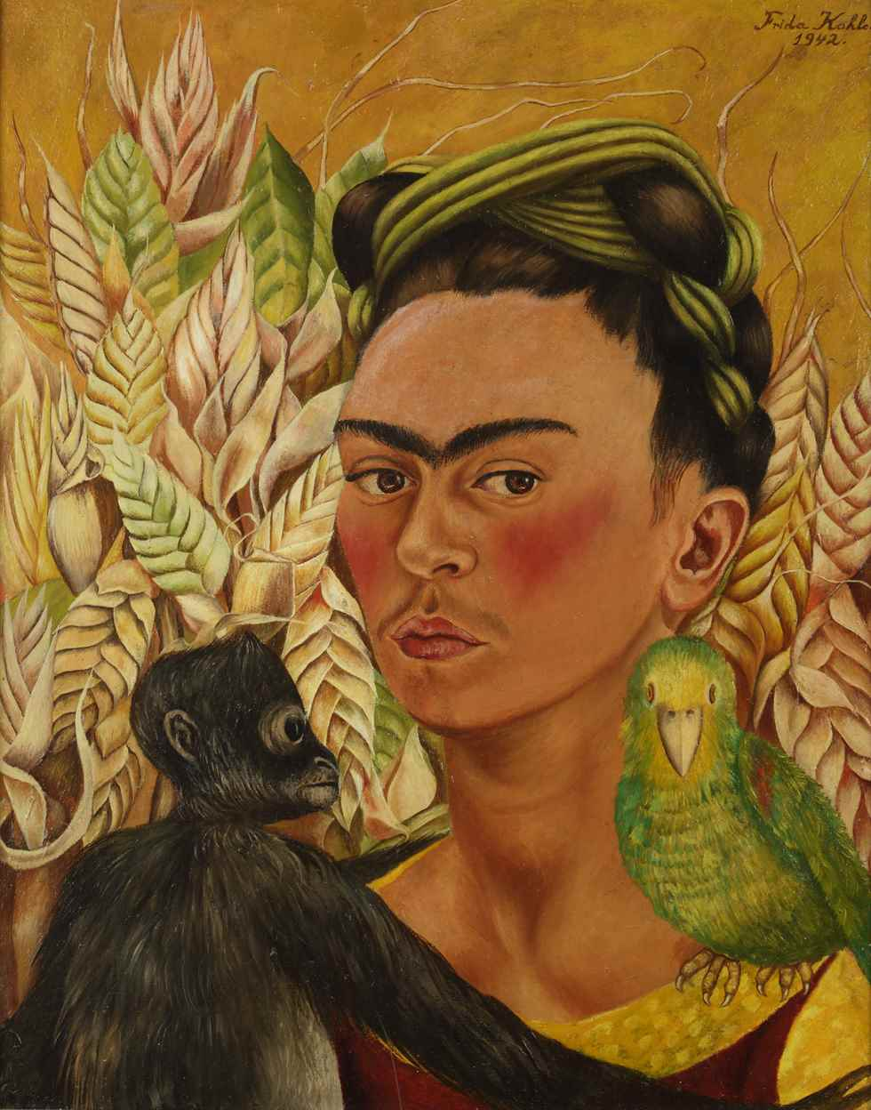](https://www.google.com/url?sa=i&url=https%3A%2F%2Fwww.sartle.com%2Fartwork%2Fself-portrait-with-monkey-and-parrot-frida-kahlo&psig=AOvVaw16Pfv6dCLPegBlGTqQTfUX&ust=1612127096932000&source=images&cd=vfe&ved=0CAIQjRxqFwoTCPCV1cnHxO4CFQAAAAAdAAAAABAP)