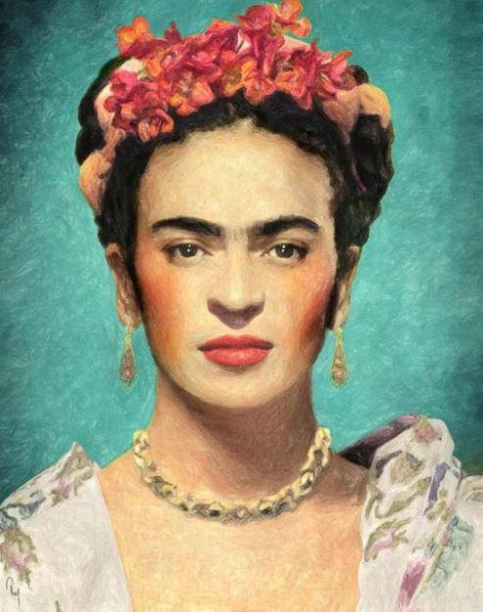
Frida Kahlo
Have a look at various self-portraits by Frida Kahlo and consider the following questions:
- Do you notice any similarities in her paintings?
- What do you notice about the colours of her self-portraits?
- How do you think Kahlo was feeling when she painted her self-portraits? Why?

Today, your task is to sketch you own self-portrait with pencil. This should include your head down to your shoulders only (like in Kahlo’s picture on this page). Sketch your face, hair and clothing. Remember, the technique of sketching means that we press on lightly with a pencil so that we can rub mistakes out without the pencil leaving ugly marks on the paper. You should use small strokes of your pencil and try to draw from top to bottom as you will have more control. You might want to practise sketching first.

*You might want to use a mirror or a photo of yourself to really think about the shape and features of your face and hair. Do not add colour to your sketch today. We can focus on this next week. Take your time. Don’t rush!

