Carrie’s War
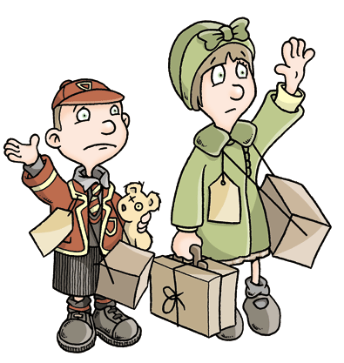
Comprehension Questions – Chapter 2
Orange book cover, cover with a house on fire, cover with just a girl’s face, black number = same page in books.

1. Why does Carrie call Nick a “Dustbin”? (Page 14, 15, 16)
2. What did Nick and Carrie have with them when they left their mother at the train station? (Page 15, 17, 17)
3. Why did Albert think that Carrie might call him Jam, Jelly or Peanut Butter? (Page 18, 19, 19)
4. Why did Carrie worry that no one would want to look after her or Nick? (Page 20, 22, 20)
5. What type of shop did Mr Evans own? (Page 21, 23, 21)
6. What word has the same meaning as quiet on page 22, 24, 21?
7. What made Carrie despair on page 23, 25, 22?
8. Why is Nick afraid of the outdoor toilet? (Page 26, 29, 24)
9. How come the children’s bedroom was so dark? (Page 28, 31, 26)
10. What phrase tells us that Nick was holding Carrie tightly? (Page 28, 31, 26)

Answers
- She calls him a dustbin because we fill dustbins with rubbish/unwanted food. Nick had filled himself up on food. Therefore, she likened him to a dustbin.
- Gas masks slung over their shoulders; names on cards around their necks.
- We can assume that Albert is often called this due to his surname being Sandwich and the fact that he’s warning Carrie not to call him any of those things.
- She worried because Nick looked white and had traces of sick around his mouth. Therefore, she was certain no one would want to take them.
- A grocery shop.
- “hushed”
- The fact that everything was really clean. She thought that she might accidentally make something dirty.
- He thinks there will be spiders in there.
- There was no light from the window because the black-out blinds were drawn.
- “clutched at her and wound himself round her like an octopus, or ivy”.

