Guided reading homework- Blackman
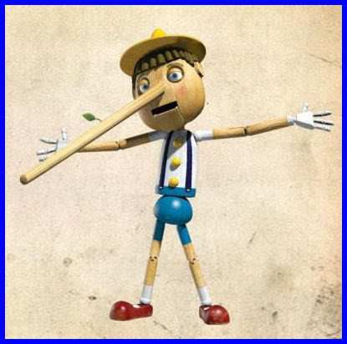
Please read up to chapter 29- chapter 28 is what these questions are based on.
- What does it mean by “the lie grew and grew”?
- Find evidence that suggests the Queen doesn’t believe that they would return the crown jewels.
- How did Gran manage to befriend the Queen?
- What do you think “Pardon” means in the context of this story? Why?
- On page 252, which word do you think means the same as “tolerate”?
Pre-read chapter 29 + 30- What are your feelings about Mr Parker?

