Guided reading homework- Fletcher
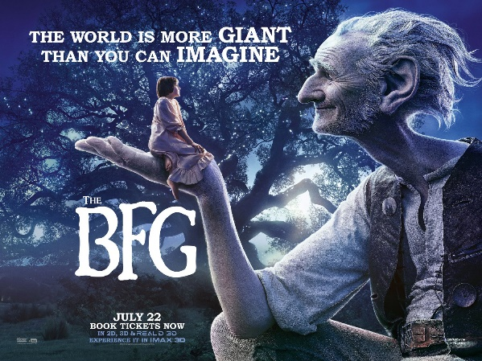
Please read “A Trugglehumper for the Fleshlumpeater”
- Why does the BFG say humans are not as old as they say they are?
- Can you find 3 words that are used to describe the giants in a negative way on page 81?
- Why did the Fleshlumpeater rise up off the ground when he was asleep?
- What is the title of the chapter referring to?
- Why did Sophie have no sympathy for the Fleshlumpeater?
Pre-read- Read “Dreams” and create 2 true or false questions to ask the group next week. Make sure you know the answers!

