Cycle of birth and death
Reincarnation is a key belief within Hinduism. In Hinduism, all life goes through birth, life, death, and rebirth and this is known as the cycle of samsara. Our actions in this life, our “karma”, affects our future incarnations. Kindness leads to good karma, whilst selfishness leads to bad karma. The soul may be reincarnated thousands of times.
A person gains good karma for doing good things in life, such as helping others through following their dharma.
In Hinduism, ‘dharma’ means duty, religion, virtue and morality; it is a central part of a Hindu’s daily life. Hindus believe that there are right and wrong ways to behave so they must behave correctly, follow the moral law and take their duties seriously. Dharma refers to the duties that a Hindu should follow in life. According to dharma, it is best to do the right thing at all times
For example, a pupil’s dharma is to work hard at school; the parents’ dharma is to raise and support their family; and the dharma of the police is to protect others. At different stages of a Hindu’s life, their dharma will change, however, it is everyone’s dharma to be kind, honest, religious and to be a good person in society.
These are the 5 daily duties that a Hindu is asked to keep in order to help them to do the right thing in any situation:
- Worship God
- Study the sacred books
- Think about and reflect on the wise words of elders and ancestors
- Give food to humans and animals in need
- Serve guests with love and respect

According to this belief, all living things have an atman, which is a piece of Brahman, or a spirit or soul. It is the atman that moves on into a new body after death.
An atman can go into the body of any living thing, such as a plant, animal or human. Once a living being dies, its atman will be reborn or reincarnated into a different body depending on its karma from its previous life. For example, if a person has good karma in a previous life, then their atman will be reborn or reincarnated into something better than they were previously. A person gains good karma for doing good things in life, such as helping others through following their dharma.
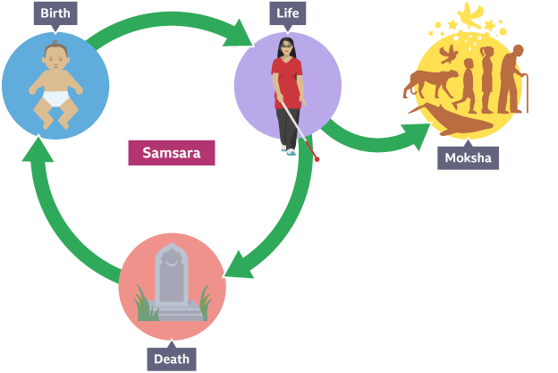

A Hindu’s ultimate goal in life is to reach moksha. The end of the cycle is called Moksha, which can be reached if you live the best life you possibly can. It makes you at one with God and sets you free from having to be reborn on this Earth again. Moksha means liberation or freedom from samsara and it can only happen after a Hindu has been reborn many times. If a Hindu gains good karma from many lifetimes, they will have gained ultimate knowledge and have freed themselves from the constraints of the material world. Once this happens, a Hindu’s atman no longer needs to be reborn into another being and is ready to be free from samsara. As a result, the atman will achieve moksha and will be re-joined with Brahman.
Believing in reincarnation affects how Hindus think about death. Bodies are burnt after death, to symbolise the quick release of the soul to begin its next life. Hindus believe that death is a new beginning for the soul of their loved one.

