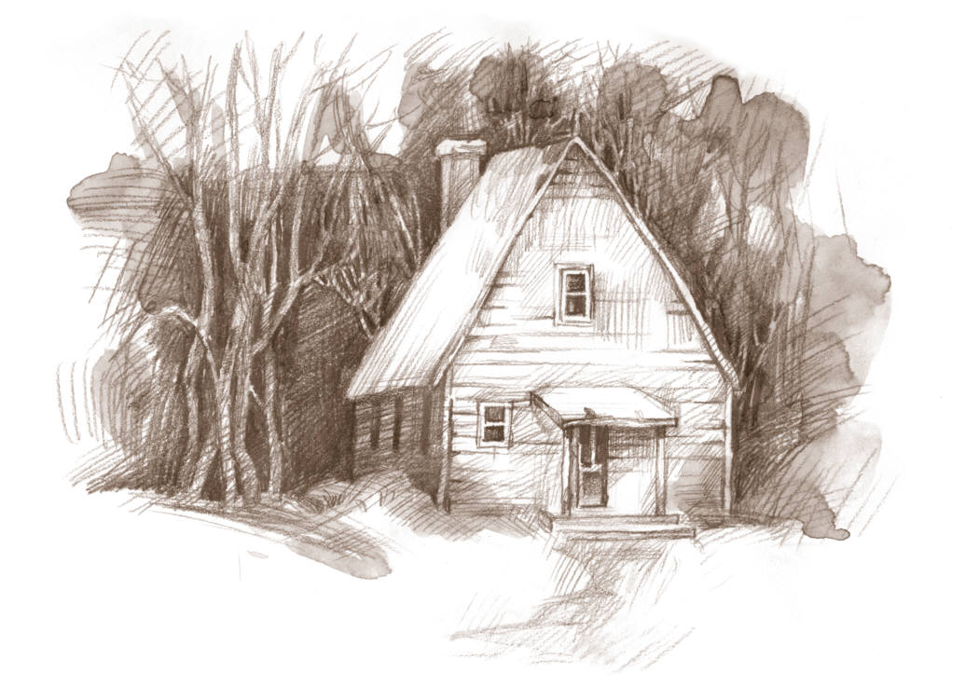
Carrie’s War – Narrative | I think...
I have written in third person.
I have written in the past tense.
I have added adverbs to verbs.
I have added adjectives to nouns.
I have used time connectives when there is a change in time in my story.
I have included complex sentences which are punctuated accurately.
I have opened sentences with ‘ly’ words
I have opened sentences with ‘ing’ words
I have opened sentences with ‘ed’ words
I have included descriptive words.
I have included a range of punctuation . , () - ? ! ’
I have punctuated speech accurately.
I have made sure there is a new line for each new speaker within a paragraph.

