TEXT HERE
7th October 2016  Term: Autumn one Week: five

Reception Class Newsletter

This week, we did not have our usual celebration assembly due to Harvest so new stars were not chosen.
Young children, sometimes, don’t understand why they have to wait to be the star of the week. Please remind your child that they are all little stars and will eventually have a turn! We carefully record when and why each child is chosen to make sure it is fair.


Our VIP’s this week are Finley B. and Jessica.
Keep up the fantastic manners!
Homework
Many thanks for all the homework that has been sent in so far. We have a special board in the classroom to display examples of homework done by the children. Please return the homework folder in the zipped plastic wallet on Wednesdays.

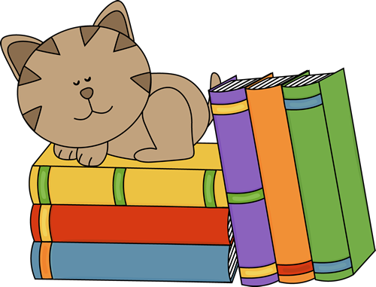
Reading books
Next week your child will bring home a self-chosen reading book. Some of the books have no words in them so the children can try to make up a story to match the pictures. Important skills are gained from discussion books and these are often dismissed as being too easy. Children have the chance to read into the pictures, name characters and describe story settings. Reading books will be changed on Mondays, Wednesdays and Fridays.

Have a lovely weekend,
Mrs Cheadle, Mrs Thompson and Miss Kirby

Our adventures with “Elmer the elephant” have continued this week. The children have been talking about Elmer and have tried hard to record their ideas. They have also been adding the finishing touches to our paper mache Elmer. Look out for the finished results when it goes on display by the entrance to the hall.

In maths, we have continued to handle and interpret data. The children have loved going around the classroom to ask their peers “Which is your favourite fruit?” They have completed their own tally charts to record the votes. The children have also helped to create a class graph to display the results in a different way. Strawberries were the clear winner with oranges a close second.

During Read Write Inc. we have looked closely at the formation of t, i, and n as well as hearing the sounds they make within words. The children have been working hard to segment and blend cvc words e.g. mat, mad, sat, sit, sad, pin, pan etc. We have been busy checking individual knowledge of letter sounds and blending skills as it was clear that some children were ready for more challenge. Next week we have a second group of children who will start to learn friendly letters (ch, sh, th, ng, nk). Every class has a range of abilities and each child will be carefully monitored to make sure they have the right level of challenge. Please do not compare your child to another in the same class. Some children learn quickly and then have a consolidation period. Other children seem not to progress then suddenly, something clicks, and they come on in leaps and bounds. We will let you know if there is anything to be concerned about.

Today we had our Harvest Assembly and the children were very brave to stand up and share their Busy Bee song. They have also really enjoyed learning the other Harvest songs alongside the older children. We chatted about how sometimes adults had to go to work and might not be able to come and watch.

Dates for your diary
Wednesday 12th October- Reception Parent Lunch.
Please be ready in the school entrance hall at 11.55am if you have ordered a lunch.

Thursday 20th October – Reception “Welly Walk”
Still time to volunteer if you would like to come along and help!

Parents Evening
Remember to return your slip for a parents evening appointment.

