
Welcome Back Year 1

Dear Parents/Carers,


Welcome back to the Summer term. We hope that you have had a relaxing and enjoyable break and are ready and eager to start our final term in Year 1.

Topic
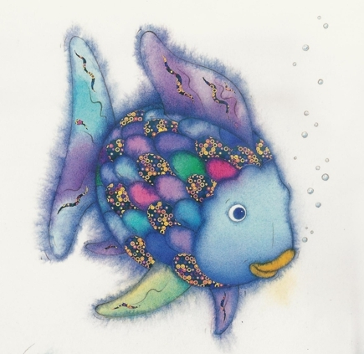
Our new topic for the Summer term is ‘Under the Sea’. We will be exploring the magical world that exists below the surface of our seas and oceans. As part of our learning we will be finding out about the various creatures that live under the sea and exploring their vibrant colours. Part of our topic will involve learning about Australia, The Great Barrier Reef and how to protect it. Our learning will focus around a number of texts including The Fish Who Could Wish, Grandad’s Island and The Rainbow Fish.

In Science, we begin this term learning about Plants. We will be planting and caring for seeds to help us to think about what a plant needs to grow. Our learning will also take us outdoors to identify common plants found in our school environment and in our gardens.

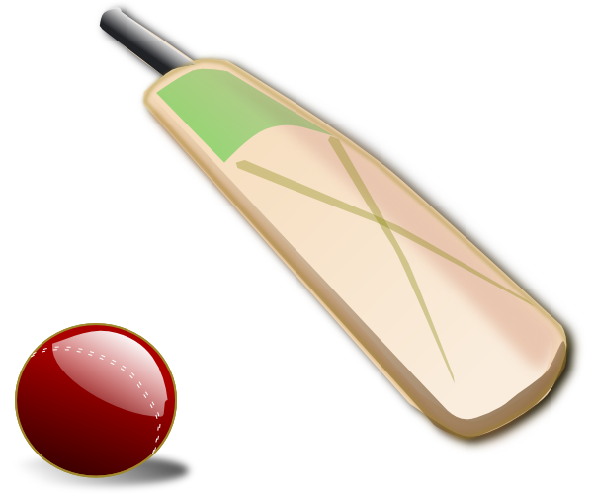
PE

PE lessons will be on Tuesdays (Mr Hancock) and Thursdays (Miss Robinson). However, please ensure that your child has their PE kit in school every day as we may occasionally have PE on another day. We will be outside as much as is possible. Please ensure that pumps still fit and that everything is labelled clearly as we struggle to return items to their owner if we don’t know who they belong to.

Homework

Reading books will be changed on a weekly basis following Guided Reading sessions on an allocated day (Monday). Guided Reading sessions have already begun and a task will be set on a Wednesday to be returned by the following Monday (yellow book). Please ensure that Guided Reading books are returned to school once the homework is completed. Please read with your child as often as possible and make comments in their planner. Planners will be taken in overnight on your child’s allocated Guided Reading day and this is my opportunity to read any comments you may have written.
Spellings will continue to be given out to practise on a Thursday (little red book) and will be checked the following Thursday.

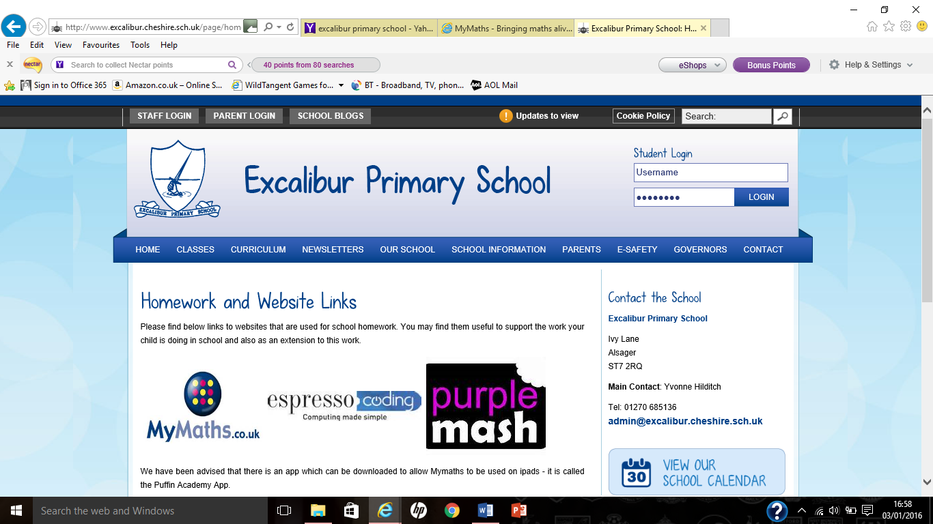
My Maths homework will continue to be set on a Friday to be completed by the following Friday. My Maths homework may involve a My Maths activity or a link to an activity on another website (which will not give a ‘score’). The homework will usually link with what we have been focusing on in class.
A link to My Maths can be found on our school website under Curriculum →Homework →Website Links (the password is in the front of the planner).

If you have any concerns or need to give me a message please speak to me in the morning, if it is a quick message, write in the planner and ask your child to hand it to me in the morning or ring the office who will pass the message onto me.

Thank you for your continued support.
Yours faithfully

Miss C Robinson and Mrs K Newbould

