Welcome Back Year 5

Dear Parents/ Carers,

Welcome back to school and the new term. I hope you have had a lovely Easter. This is just a reminder about a few things and to tell you about what has been planned for your child for the final term of Year 5.

Topic
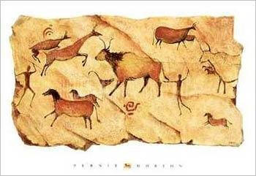
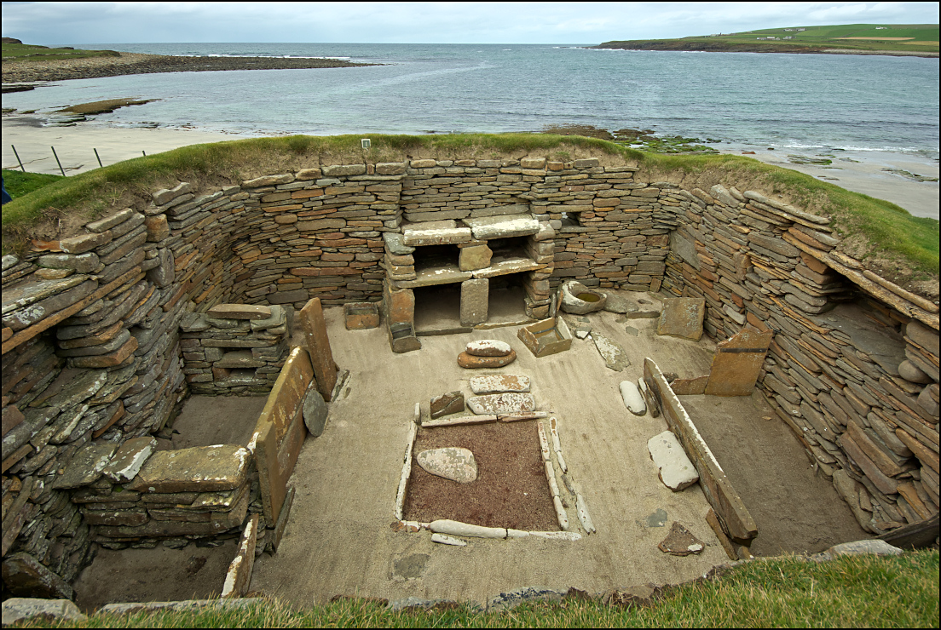
Our new topic for the Summer Term is ‘Stone Age to Iron Age’. We will be investigating the changes that occurred from the Stone Age, through the Bronze Age to the Iron Age. Through this topic we will be looking at artefacts as evidence to help make assumptions about life during these vast time periods. We will also look at the development from hunter-gatherers to farming, the changes in materials used for tools and houses as well as focusing on key discoveries such as Skara Brae and considering why children worked in copper mines.

English
In English, will we be reading a book called The Abominables by Eva Ibbotson. The Abominables is set in the Himalayan peaks of Nanvi Dar. Also, we will be using this text to create a descriptive piece of writing. We will relate some of our writing to our topic: Instructional writing - How to Wash a Woolly Mammoth; cave painting narratives; stories in the style of existing authors and creating a guide for a Stone Age tourist.

Practical information
The children should arrive at school by 9 am but are encouraged to come in at 8:50 am as early morning activities will help them to settle quickly and get their brains in to action!

It is important for children to drink water throughout the day especially now the weather is becoming warmer. Therefore, children may bring in bottles of water each day so long as the bottle has a secure lid. Please can you remind your child to take their bottle home every night for washing and refilling.

Please try to make sure that all your child’s clothes are clearly labelled with their name. It’s during this time of year, when jumpers are taken off, that they are lost or misplaced! Any lost property can then be easily identified.

PE
For the first part of this term, one of Year 5’s PE sessions will be swimming at the leisure centre on a Wednesday. Please ensure that your child brings their swimming kit to school on the appropriate days. Labelled PE kits should be in school every day, please.

Homework

A few reminders about homework. My Maths homework will usually be set online on a Friday to be completed by the following Friday. Spelling homework will be given out on the day of your child’s Guided Reading session to be tested the following Friday. This ensures that all children have at least a week to learn the spellings. Guided reading homework is given out on your child’s guided reading day and should be returned by the same day the following week. Although children in Year 5 are encouraged to read independently, I would urge you to continue listening to your child read whenever possible as fluency is an essential part of reading and helps comprehension.

Planners should be in school every day and children are encouraged to make comments about what they are reading at home in them. If you have any questions or queries, please do not hesitate in contacting me or you could leave a note in your child’s planner.

Lastly, I would like to thank you for your support throughout this year. Mrs Beale will be taking over in Year 5 on Monday 30th April and I officially begin my maternity leave on Friday 4th May. It has been a pleasure to work with your children and I wish them lots of luck for the rest of the term and their time in Year 6.

Yours sincerely

Miss A McArdle

