13th September 2024  Term: Autumn 1 Week: Two

## Reception Class Newsletter

Phew! We have done our first full week and what a busy week it was! Thank you again for helping things to run seamlessly. Everyone is doing so well. We know that starting school full time is no mean feat, with so many new people and routines to get used to. Any tears on arrival have stopped very quickly. The classroom is set up so that the children have things to be getting on with when they walk through the door which helps. We had our first Helicopter stories and Dough Disco sessions, we met Fred the Frog and played some games with him (there will be more on him on Seesaw next week). We tried to keep in a space as we travelled around the hall in PE. Back in the classroom we have continued to sing our counting song, ‘Let’s count to 10’ which can be found on YouTube. We have also been counting forwards and backwards to 10. We have been trying to hold up the right number of fingers to correspond to the numbers in the song. We learnt a poem ‘Chop, Chop’ and had lots of lovely stories and songs. The children have continued to explore the environment and the resources that we have, as well as making and developing new friendships.

**Stars**

Today we had a special Reception stars assembly. Every week each class chooses 2 children to be our ‘stars of the week’. The stars are celebrated in a weekly assembly and presented with a special certificate explaining why they are a star. They also get a metal star badge to wear for the week. The star badges are returned the next Friday. We will join the rest of the school for their stars assembly later in the school year, for now we will be separate. It’s never an easy choice to choose just 2 children. This week we could have easily have chosen the whole class.

Super stars 



Congratulations to this week’s stars

Andrian and Alfie



Well done!

*Thank you again for all the wonderful ‘All About Me’ boxes that have already been sent in. We just have about 3 or 4 that haven’t come in to school yet. We are planning to start sharing them next week so would love it if they could all be here as soon as you can.*

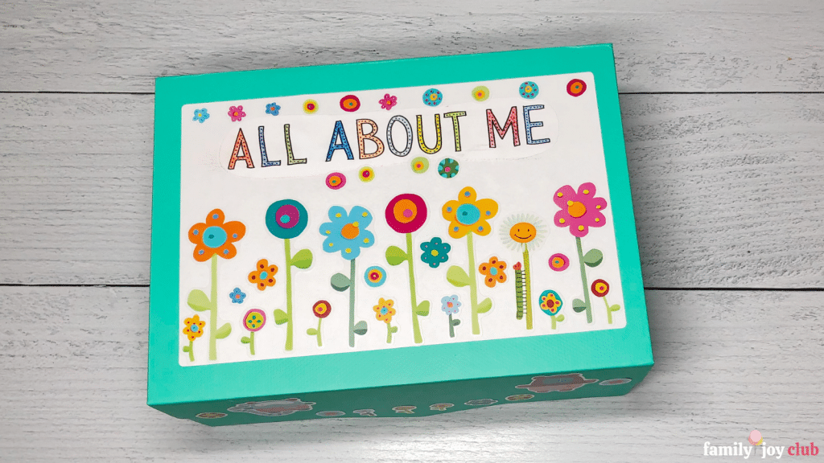

**Home Story Books**

We have loved reading your comments in your child’s reading diary. It’s great to see so much reading at home. Sharing a story with your child each day is a really brilliant way for you to support your child’s language and reading development. Here are a couple of short videos to watch explaining why reading to your child is so important and what you can do to make it even better.

Why read to your child

<https://www.youtube.com/watch?v=2UmwXQwx5gk>

10 things to think about when you read to your child

<https://www.youtube.com/watch?v=eqhwJhd_fNM&t=1s>

*Have a lovely weekend, from the EYFS team*