***Stars of the Week – 27/09/2024***

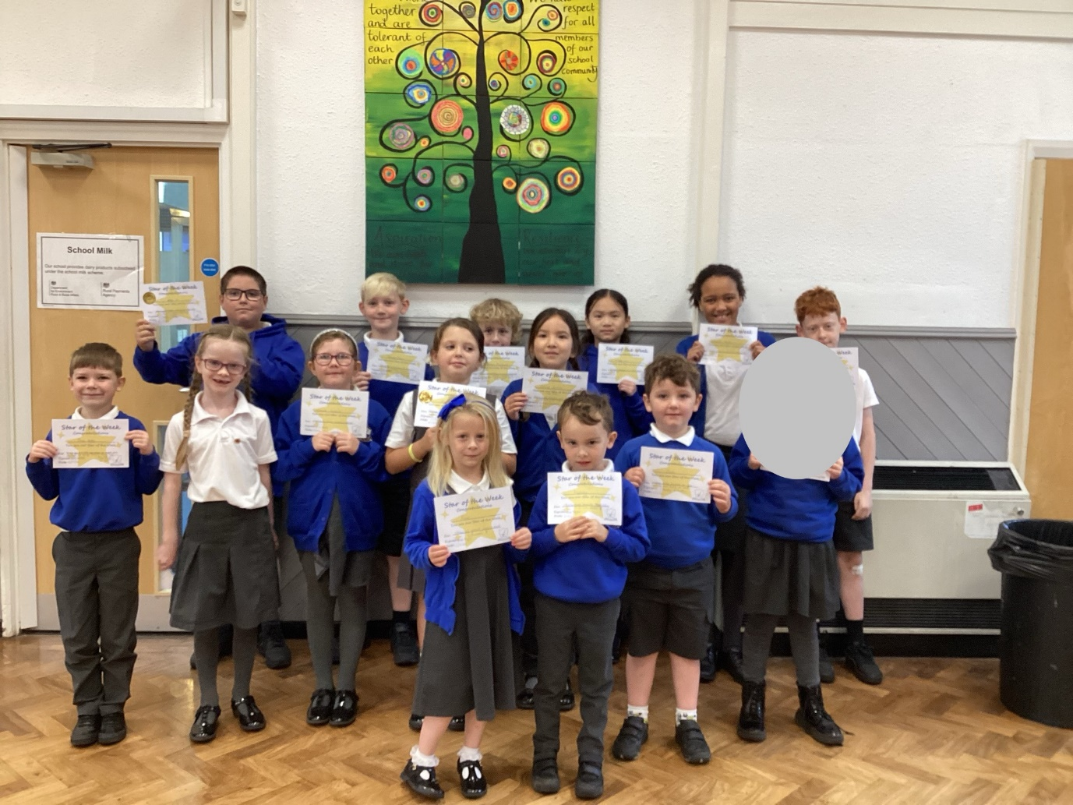

**Year 1:**

* Rafferty for challenging yourself – especially in maths.
* Rose for showing great focus and enthusiasm.

**Year 2:**

* Zach for always being focused on your learning and trying so hard.
* Sira for your fantastic focus! You’re always ready to learn and try so hard.

**Year 3:**

* Theo for always offering to help, even though you didn’t make the mess and for always having a smiley, happy face when you walk through the door.
* Bella for taking such pride in your workspace and classroom; always making sure it’s tidy and clean, even for other children.

**Year 4:**

* Florence for being such a brilliant helper to others.
* Jessica for showing great determination.

**Year 5:**

* Thomas for super presentation in your maths book and for always being ready to learn.
* George for showing resilience in all lessons. You’re really pushing yourself and achieving.

**Year 6:**

* James for being superbly focussed at all times.
* Hailey for consistently displaying our school values at all times.

**Head Teacher’s Award:**

* Max for conscientiously carrying out his year 6 responsibilities.

**Tree Tops:**

* Esme for being super helpful and kind everyday of Tree Tops.