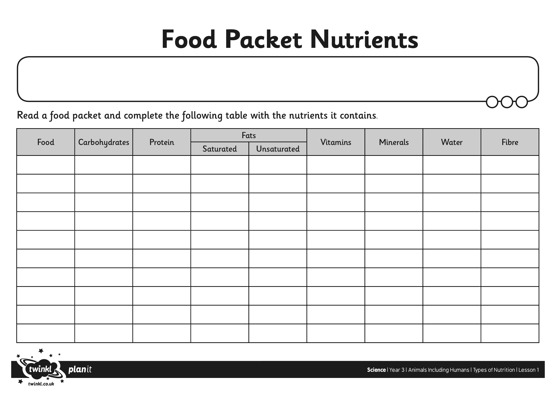
Find some different food packets that you have in the cupboards.

