LO – I can solve multiplication problems using arrays. (Mastery)

- There are 8 biscuits in a packet. Jane buys 4 packets for her party. How many biscuits does she have?

- There are 4 fireworks in a box. Sam has 7 boxes. How many fireworks does he have altogether?


- The teacher needs each table to have eight pencils. There are 3 tables. How many pencils will she need? ___________


- Ben wants to buy 4 lollies for each of his 9 classmates.
How many lollies will he need to buy?

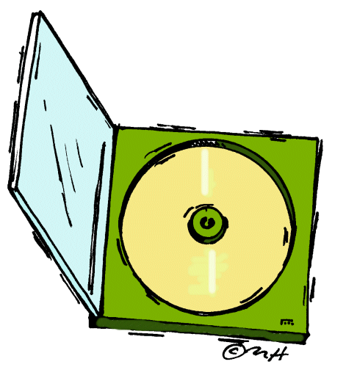
5) Lucy has 4 CDs in each rack. She has 7 racks. How many CDs has she altogether? ______________



6) 11 children have completed their sticker card. Each card holds 3 stickers. How many stickers has the teacher given out? ___________

