Volcanic Eruption Poem

In your poem, use similes and metaphors to describe the eruption.
E.g. The volcano is a gigantic upside-down ice cream cone
It roars like a fiery dragon awoken from its sleep
Also use personification, a type of metaphor where you make something non-living sound like a human or living creature,
E.g. Lava spews out of the volcano’s stomach

Adapt the writing frame below to suit your poem or write your own one.
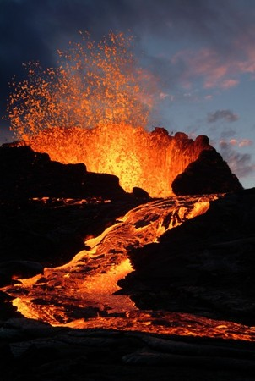
When the volcano awakes it is like

As it erupts, it is a

The earth violently

And makes

Suddenly, the crater blows

The explosion is as

Fiery lava

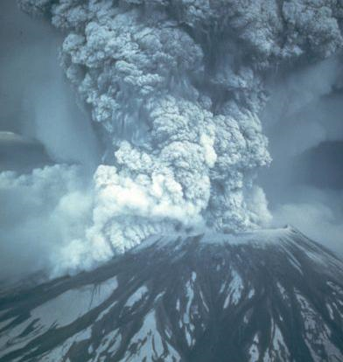
It

everything in its path

The smoke and ash

And the air is like

The smell of

And still the lava

Until

