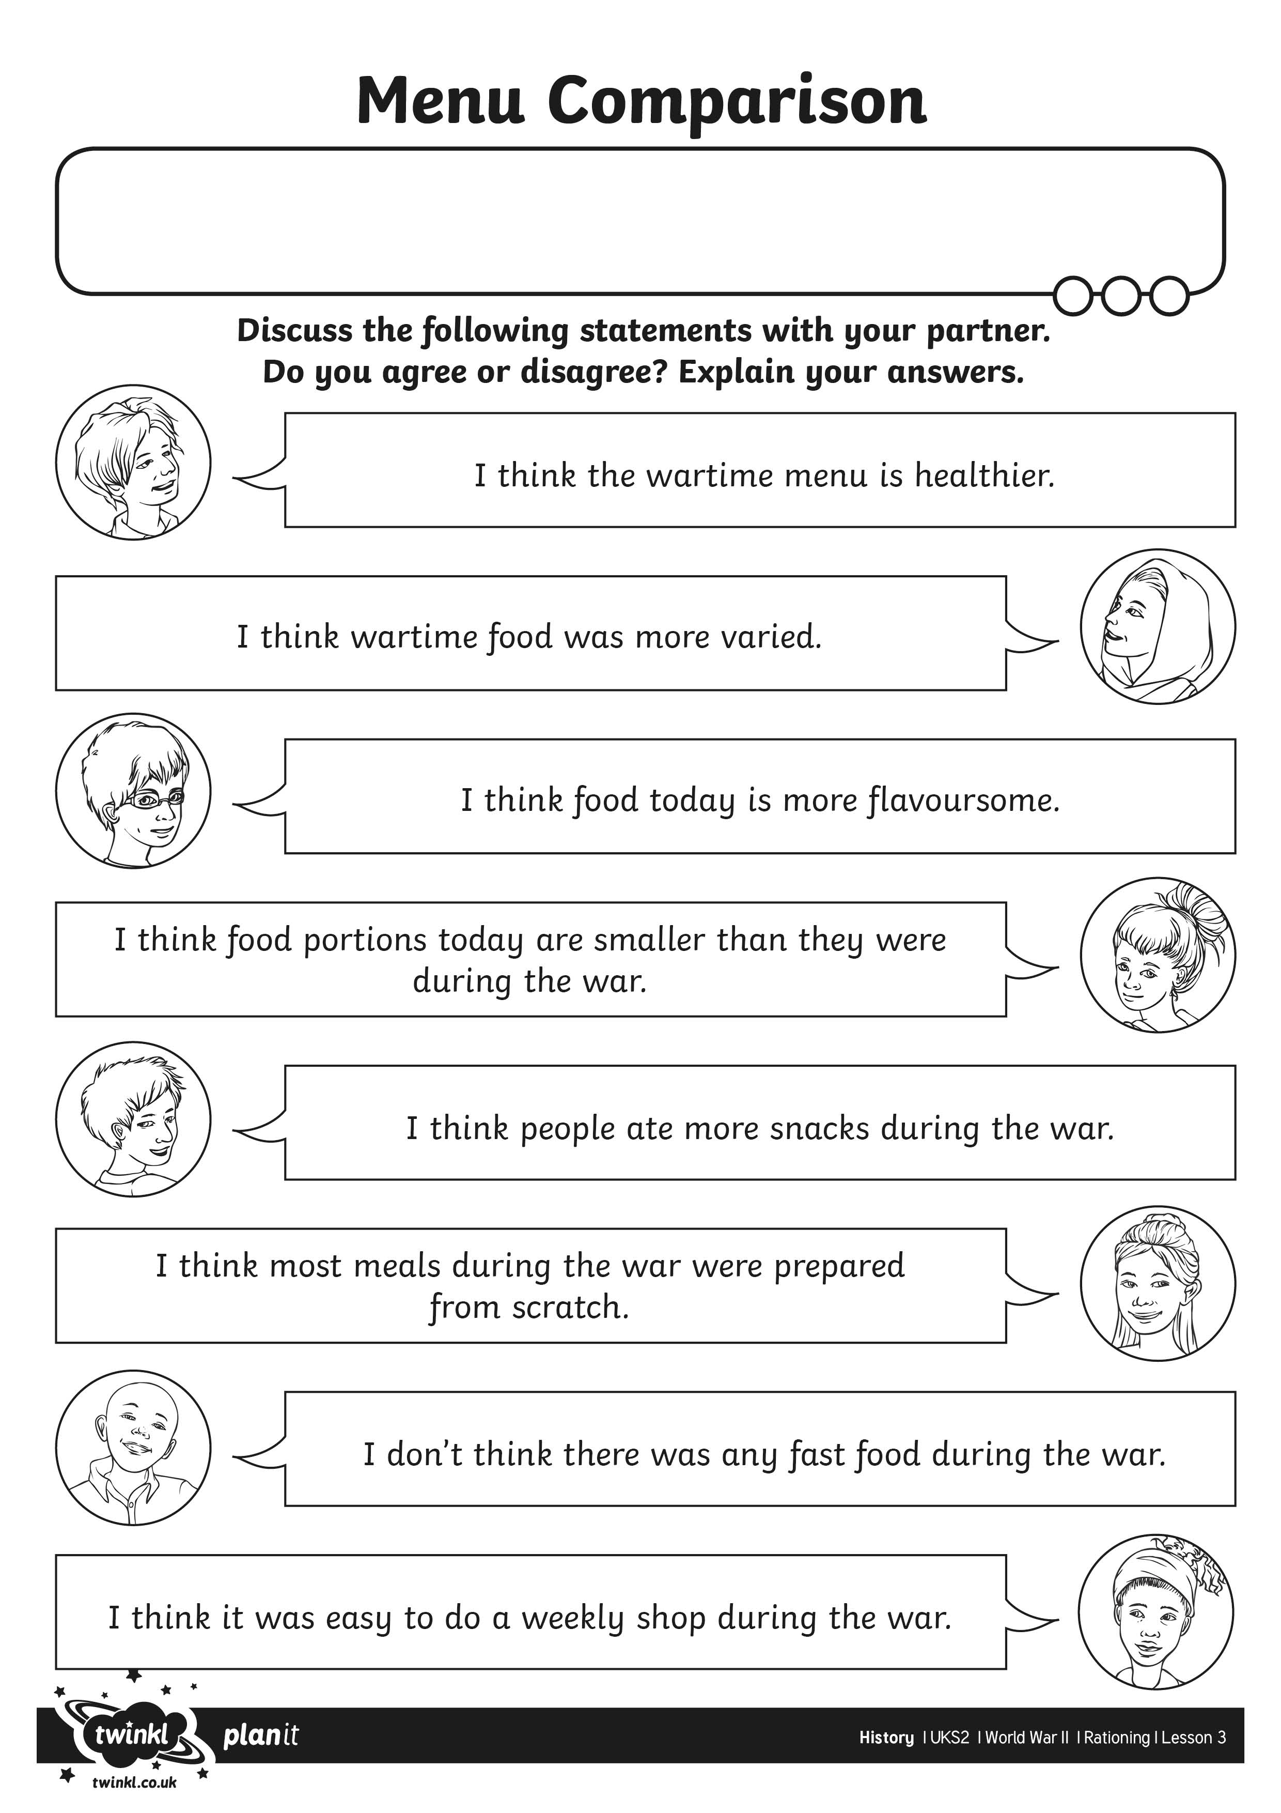
I can compare a wartime menu with a modern day menu.

